Math 1314 Test 1 – Chapters 1 and 2

NAME: _________________________________
DATE: ________________________

Instructions
Complete the entire test on separate paper. Once complete, scan the document and submit on eCampus.
EACH QUESTION is worth 20 points. Bonus worth 5 points.

- Graph the function, f (x) = – (x + 4)³ – 2, describe the transformation performed on the parent function, and state the domain and range in interval notation.

a) Graph: f (x) = – (x + 4)³ – 2
b) Transformation description:
c) The domain of the function in interval notation is _____________________.
d) The range of the function in interval notation is _____________________.

- For the function:
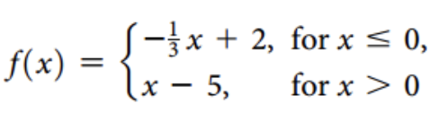
a) Graph the function:
b) Write the Domain in interval notation: _______________________
c) Write the Range in interval notation: _____________________________
- The expression $\frac{f\left(x+h\right)-f(x)}{h}, h≠0$ is called the difference quotient.
Find and simplify the difference quotient for the following function: f (x) = x² – 5x + 2
The difference quotient is _________________________________________.
- Write an equation for the parent function, f (x) = x², under the following transformations:
horizontal shift left 10 units, vertical stretch by 7, reflection over the y-axis and a vertical shift up 12 units.
- For the given functions, find each of the composition functions below and the domain of each.
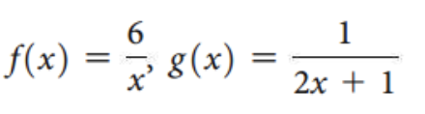

  - ( f ∘ g )(x) = ( f ( g(x)) =
  - ( g ∘ f )(x) = ( g( f (x)) =
  - What is the domain of ( f ∘ g )(x)?
    - $\left(-∞,-12\right)∪\left(-12, 0\right)∪\left(0,∞\right)$ C. $\left(-∞,0\right)∪\left(0,∞\right)$
    - $(-∞,-\frac{1}{2})∪(-\frac{1}{2},∞)$ D. $\left(-∞,-12\right)∪\left(-12,∞\right)$
  - What is the domain of ( g ∘ f )(x)?
    - $\left(-∞,-12\right)∪\left(-12,∞\right)$ C. $\left(-∞,-12\right)∪\left(-12, 0\right)∪\left(0,∞\right)$
    - $\left(-∞,0\right)∪\left(0,∞\right)$ D. $(-∞,-\frac{1}{2})∪(-\frac{1}{2},∞)$

BONUS:
(5 points) For the graph below state each of the attributes listed:
- Domain in interval notation: _______________________________________
- Range in interval notation: _______________________________________
- Absolute MAXIMUM value: ________________
- Absolute minimum value: __________________
- Relative/local MAXIMA: __________________________________________
- Relative/local minima: _____________________________________________
- Intervals where function is increasing: __________________________________________
- Intervals where function is decreasing: ________________________________________

